Customer Churn Analysis Report
This report outlines the process of selecting, building, and evaluating a machine learning model to predict customer churn. The goal is to identify customers at risk of leaving and provide actionable insights to help mitigate this risk for Lloyds Banking Group.

Data Identification and Collection
The data set used in this analysis was provided across multiple structured sources and merged using a unique CustomerID to form a single analytical dataset. The combined data includes the following key components:
- Customer Demographics: Age, gender, marital status, and income level
- Transaction History: Customer spending behaviour and transaction-related information
- Customer Service Interactions: Service interaction records and resolution status
- Online Activity: Digital engagement indicators such as login frequency and recency
- Churn Status: A binary indicator identifying whether a customer has churned (1) or not (0)
Datetime variables (such as last login or transaction dates) were transformed into recency-based numerical features (e.g. days since last activity) to ensure compatibility with machine learning algorithms and to enhance predictive relevance.

Exploratory Data Analysis
Exploratory data analysis was conducted to uncover patterns and insights that could inform predictive modelling. The analysis revealed that customer churn is influenced by a combination of demographic, behavioural, and engagement-related factors. Customers with lower digital engagement, reduced transaction activity, and unresolved customer service interactions showed a higher likelihood of churning.
These findings provided valuable context for feature selection and reinforced the importance of incorporating behavioural indicators into the predictive model.

Model Selection and Building
After considering several classification algorithms, a Random Forest classifier was selected due to its strong performance on structured tabular data and its ability to balance predictive accuracy with interpretability. Random Forest models are well suited to capturing non-linear relationships and interactions between features while remaining robust to overfitting.
The model was trained using stratified 5-fold cross-validation to ensure robustness and generalisation to unseen data, particularly given the imbalanced nature of the churn variable. Hyperparameter tuning was performed using grid search to optimise model performance, and class imbalance was addressed using balanced class weights.

Model Evaluation
The model’s performance was evaluated using multiple metrics to provide a comprehensive assessment of its effectiveness:
- Precision to assess the accuracy of churn predictions
- Recall to evaluate the model’s ability to correctly identify churned customers
- F1 Score to balance precision and recall
- ROC-AUC to measure overall discriminatory power
- Confusion Matrix to analyse classification outcomes in detail
The evaluation results from the Colab notebook demonstrate that the Random Forest model performs well in distinguishing between churned and non-churned customers. The ROC-AUC score indicates strong predictive capability, while the confusion matrix highlights a reasonable balance between identifying churners and limiting false positives.
Feature importance analysis identified key predictors of churn, including customer engagement and transaction-related features, providing valuable insight into the drivers of customer attrition.

Figure 5: Confusion Matrix of the Churn Prediction Model
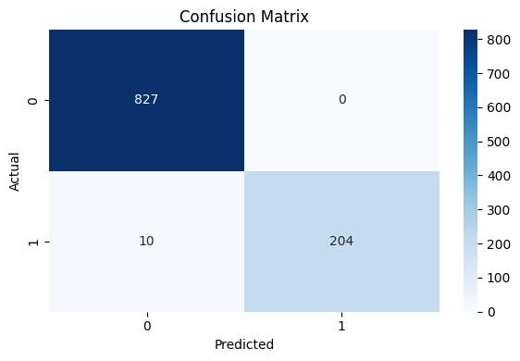

Figure 6: ROC Curve for the Random Forest Model
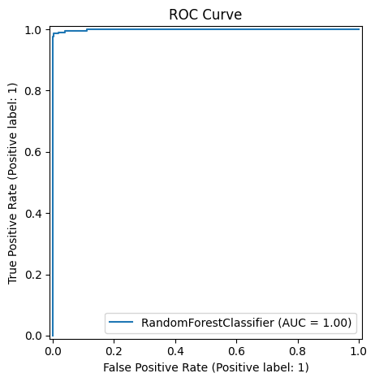

Figure 7: Feature Importance of Top Predictors
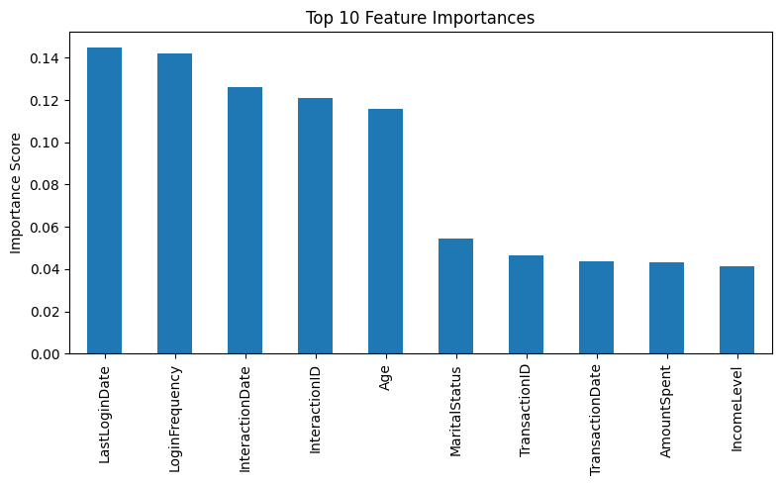

Recommendations and Business Implications
The outputs of the churn prediction model can be used by Lloyds Banking Group to proactively identify customers at risk of leaving and implement targeted retention strategies. These strategies may include personalised offers, proactive customer support, and enhanced engagement initiatives aimed at high-risk customer segments.
The interpretability of the Random Forest model allows stakeholders to understand the key drivers of churn and align interventions accordingly. Future improvements could include incorporating additional behavioural data, refining decision thresholds based on business cost considerations, and exploring more advanced models such as Gradient Boosting or XGBoost to further enhance predictive performance.

